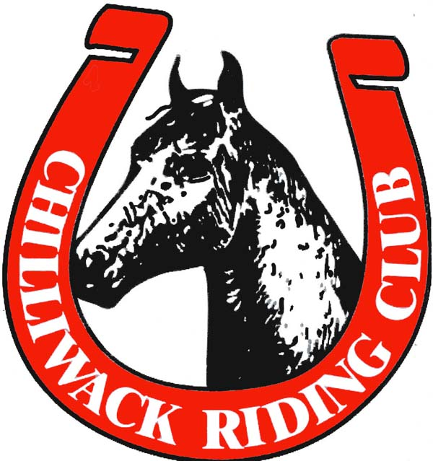

2020 Annual General Meeting

ATTENDANCE:
Meeting called to order at 7:07pm via Zoom online meeting format. 13 members in attendance.
Riesa Kyne read minutes from the 2019 AGM. Riesa Kyne makes motion to adopt 2019 minutes as having been read; seconded by Barb Bodholdt.

TREASURY REPORT
October 2019 Closing Balance: $8,173.23
October 2020 Closing Balance: $5,5564
Major Expenses: arena rentals (Open Ride and gymkhanas), year-end awards, annual operating costs, banks fees.
Major Incomes: gymkhanas, memberships, online auction, buckle sponsorships

Total Operating Expenses for Nov 2019 to Oct 2020: $2589.77
Operating expenses include Capri Insurance, Website domain, HCBC, Ribbon purchases, year-end hall rentals and expenses (from 2019 AGM), Atchelitz Clubhouse fees, bank fees and other miscellaneous costs to maintain the club

Open Ride 2020
The deficit we had for the 2019-2020 season due to offering open ride to members was substantial enough that for this year we opted to charge a very low arena fee of $2 for the first few months of 2020 then increased to $5 in the summer. This increase was due to the fact that during the COVID-19 pandemic our income was minimal for several months during lockdown which overall made us see less memberships earlier in the year than usual. We needed an extra boost of income and it really helped us survive financially.

Open ride income: $721.50
Membership income: $1375.00
Arena Rentals: $1321.43
Total: $775.07

Due to the fact that we were unable to host any in person fundraisers we opted to host an online auction for which income went solely towards year end awards for gymkhanas. This fundraiser was a great success and that combined with our buckle sponsorships brought in roughly $2000 to go towards the club and help with year -end prizes!

Total income from 2020 Gymkhanas: $2,656.38
Income from Buckle sponsorships and online auction: $2160.00
Ribbon Expenses: $417.88
Total money used for year-end: $2600.00
Net income: $1,748.50

ARCHIVES
Photos have been added to the collection from the year’s events.
The Club House has been fine for storage. The ATA have allowed the Club to renew the rental for another year. One space heater has been working to keep the damp down inside the Club House.

BOOKINGS
Bookings have been fairly easy to get, even with COVID-19. There have been some changes made by Heritage Park, but they have seemed eager to accommodate the Club and have been helpful in getting us the bookings we need.

CLINICS
Nothing to report

DRILL
Nothing to report

FUNDRAISING
We weren’t able to host our usual fundraisers this year. Barb Bodholdt and Megan McKay organized a Facebook-based auction. The funds from this event went directly to Year-End awards. This was a great success netting the Club $1240 and six buckle sponsorships. There was much generosity from local businesses and people.

GOODWILL
The Club decided to donate to the Chilliwack Community Food Bank this year as part of the volunteer points requirement for Year-End awards.

Card sent to John Giesbrecht’s family for his passing
Card sent to Luanne Yellowfly on the passing of her brother, David
Card send to the family of Weston Abel, 5, who was killed by a falling tree in the Browne Creek Wetlands
Plant and card given to Corinne Kriegl for the passing of her Mom

GYMKHANA
SPEED EVENT: Because of COVID-19 we were unable to host the Speed Event this year. The restriction to the number of participants allowed would have made it impossible to pay for the event. $1128.85 in prize purchases had been made at the time of cancellation. Those prizes will be kept in inventory for the 2021 Speed Event.

There was very good, and consistent, rider turn-out for the gymkhanas this year, in spite of COVID-19. The Club did have to postpone a gymkhana in the early season, but were able to run enough for the season.

HORSE SHOW
Nothing to report

INVENTORY
The main addition to the inventory this year is the new timer set.

There is an inventory of prizes valued at $1128.85, that were purchased in the spring, for the Annual Speed Event. The event was cancelled due to COVID-19. They are stored at Barb Bodholdt's home.

Other inventory stored in the clubhouse is the PA system, timers, 2-ways radios, CD player and a few other electronics. Our club flags and poles, drill equipment, decorations, and the previous years minutes and other reports. Larger items used for our gymkhanas and horse shows are stored in our container, located on the Heritage Park site.

MEMBERSHIP
The Chilliwack Riding Club had 106 members in 2020, which included 18 honorary members.

MEDIA
Regular Saddle-Up Magazine submissions were made.

The website was updated at least monthly.

The Facebook page was updated as necessary.

OPEN RIDE
Similar numbers of riders have been attending Open Ride. There had been some restrictions because of COVID-19 and as a result masks must be worn in the holding areas and there are no chairs to be used.

SOCIAL
No social events were planned for 2020 because of COVID-19.

TRAIL
This year we held our first Poker Ride in many years. There was an excellent turn-out with a good return to the Club.

The Riding Club participated in the Adopt-A-Trail program again through the City of Chilliwack.

BYLAWS
See below

AGM/BANQUET
The awards banquet needed to be cancelled this year because of COVID-19. The awards were handed out in individual time slots to the winners from Barb Bodholdt’s garage.

Directors: Term Complete Directors: Year Remaining
Barb Bodholdt Riesa Kyne
Penny Boldt Kaitlin Tottenham
Luanne Yellowfly Corinne Kriegl
Aidan Kyne

BYLAW AMENDMENTS:
- Update Bylaw rule 7.a
  - New bylaw to read: “ by delivering his resignation in writing to the secretary of the society by email, or by mailing or delivering it to the address of the society”
- Update Bylaw rule 58
  - New bylaw to read: “A notice may be given to a member via email. If email is not available then a letter will be given either personally or by mail to him at his registered address.”

MEMBER QUESTIONS/COMMENTS
Comment:
- Would prefer to see horse shows this year.
- Answer: CRC would also like to host horse shows, but because of the added expense of a judge and very low ridership in the past few years it seems unlikely that the Club will be able to host a horse show at least while the COVID-19 pandemic. Revenue streams have been severely impacted and the Club cannot consider hosting an event that will likely lose money.

New Directors: Tanya Jones, Tanya Thompson, Megan McKay and Simon Tellier nominated and sworn in by Riesa Kyne. Barb Bodholdt and Penny Boldt also let their names stand for another two-year term and were sworn in as well.

Meeting adjourned at 7:52pm

