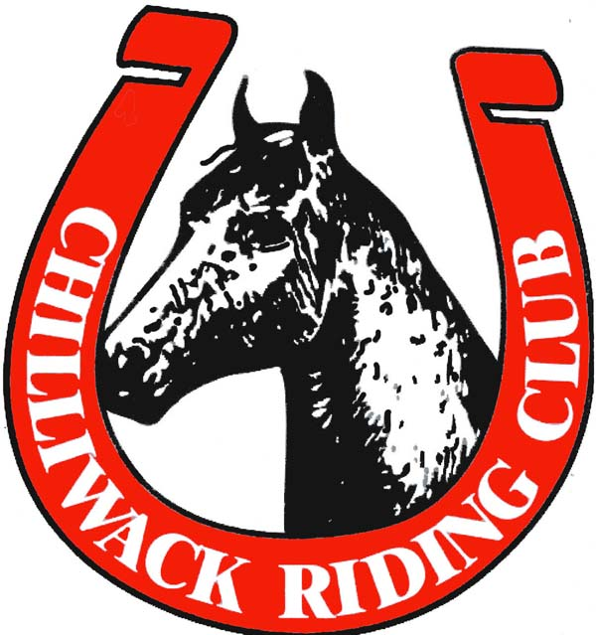
2021 CHILLIWACK RIDING CLUB
MEMBERSHIP APPLICATION FORM

NAME:
BIRTHDATE: HCBC#:
ADDRESS: CITY:
POSTAL CODE: PHONE:
EMAIL ADDRESS:

TYPE OF MEMBERSHIP (circle one):

Single $30 | Single, Youth $30 | Family $45 | Prorate, Single $40 | Prorate, Family $60 | Honourary

ADDITIONAL FAMILY MEMBERS (living in same house):
NAME DATE OF BIRTH HCBC#

By signing this document, I hereby certify that I, and all or any family members listed, agree to abide by the constitution and by-laws of the Chilliwack Riding Club, and the rules and regulations made by the directors of the Chilliwack Riding Club. I acknowledge that some of the activities sponsored or attended by myself and/or my family members at the Chilliwack Riding Club are potentially dangerous and may involve the risk of harm to myself and/or property. Accordingly, in consideration of the acceptance of my application for membership in the Chilliwack Riding Club, I acknowledge such risks and hereby release the Chilliwack Riding Club and its directors from any liability whatsoever, I may have to myself, and/or my family, my property, or livestock in any manner whatsoever. Membership applicants must be a member in good standing to receive a renewed membership. Furthermore, with respect to the operation of the Chilliwack Riding Club and any decisions made at General Meetings or by the Directors, all decisions shall be final and binding upon myself. I agree that in order to be accepted as an active member of the Chilliwack Riding Club, I must have a current Horse Council of B.C membership/insurance and provide proof of membership together with my Chilliwack Riding Club membership application form. I am aware that I will not be permitted to enter Chilliwack Riding Club event without proof of current HCBC insurance. I understand that my membership is not valid until payment has been received by the Chilliwack Riding Club and have obtained a current Horse Council of BC membership.

______________________________________________________ _______________
SIGNATURE DATE

